Introduction to Source Code
Version Controlling
and SVN
Version 1.0
Date 03/11/10

Copyright notice
Copyright © 2010, Cognizione consulting & solutions Pvt Ltd
All rights reserved.

These materials are confidential and proprietary to Cognizione consulting & solutions pvt
ltd/its licensors and no part of these materials should be reproduced, published, transmitted
or distributed in any form or by any means, electronic, mechanical, photocopying, recording or
otherwise, or stored in any information storage or retrieval system of any nature nor should the
materials be disclosed to third parties without the prior express written authorization of
Cognizione consulting & solutions Pvt ltd/its licensors
Revision history

Doc No: | Version no. | Change reference no. | Author | Published date | Sections changed | Description of changes
 | 1.0 |  |  | 03/11/10 |  | Base Document

CONTENTS

Purpose of the document 4
Scope of the document 4
Desired outcome 4
Targeted recipient 4
Prerequisite 4
Required Software 4
Introduction to Version Controlling and SVN 4
Version Controlling 4
Subversion (SVN) 5
Different Components of the SVN environment used in Cognizione 6

Purpose of the document

This document describes the following

- A general introduction to version controlling with particular emphasis on Subversion (SVN).

Scope of the document

This document is only a brief introduction to the vast topic of source. It doesn’t explain the following points

- Installation and configuration of SVN.
- Different SVN operations

Desired outcome

- General overview on SVN

Targeted recipient

Developers using SVN for source code management.

Prerequisite

- Exposure to multi member development environment

Required Software

None

Introduction to Version Controlling and SVN

Version Controlling

Version control also known as source control or software configuration management (SCM), is the management of changes to documents, programs, and other information stored as computer files. It is most commonly used in software development, where a team of people may change the same files.

Changes are usually identified by a number or letter code, termed the "revision number", "revision level", or simply "revision". For example, an initial set of files is "revision 1". When the first change is made, the resulting set is "revision 2", and so on. Each revision is associated with a timestamp and the person making the change. Revisions can be compared, restored, and with some types of files, merged.

Subversion (SVN)

Apache Subversion (formerly called Subversion, command name svn) is a version control system founded and sponsored in 2000 by Collabnet Inc.

Subversion is a centralized system for sharing information. At its core is a repository, which is a central store of data. The repository stores information in the form of a filesystem
tree—a typical hierarchy of files and directories. Any number of clients connect to the repository,
and then read or write to these files. By writing data, a client makes the information
available to others; by reading data, the client receives information from others.

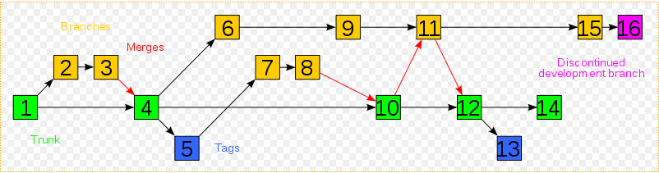
Figure 1 Visualization of a simple Subversion project

Different Components of the SVN environment used in Cognizione

The current SVN environment is composed of the following components

- Repository – The main storehouse of the source codes currently in “D:\Repository” in CCS7 machine.

- Local or Working Copies – The extracted copies in developer’s machine in which they work.

- SVN Server – It refers to the machine (CCS7) which housed the SVN repository.

- SVN Client – The software that is used by NetBeans to connect with the SVN server.

- Tortoise SVN Client – It is a third party software that is used as an interface to the SVN server.

Some General Concepts

Repository URLs - Subversion repositories can be accessed through many different methods - on local disk, or through various network protocols. A repository location, however, is always a URL. The URL schema indicates the access method. The available methods or schemas for accessing the repository is given below.
Schema | Access Method
file:// | Direct repository access on local or network drive.
http:// | Access via WebDAV protocol to Subversion-aware Apache server.
https:// | Same as http://, but with SSL encryption.
svn:// | Unauthenticated TCP/IP access via custom protocol to a svnserve server.
svn+ssh:// | authenticated, encrypted TCP/IP access via custom protocol to a svnserve server.

Table 1 - Repository Access URLs

The schema currently used by us is the “svn://”.

Server : In a SVN environment we need a place where repositories are stored. You can either store your repositories locally and access them using the file:// protocol or you can place them on a server and access them with the http:// or svn:// protocols. The two server protocols can also be encrypted. You use https:// or svn+ssh://.

Currently the server used by us is based on “svn://” protocol.

